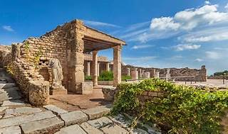

Explore

**Carthage** is a **simple dependency manager** for macOS and iOS, created by a group of developers from GitHub. [It exclusively uses dynamic frameworks, rather than static libraries, and allows you to manage third-party libraries efficiently within your projects1](https://www.kodeco.com/7649117-carthage-tutorial-getting-started).

Here are **five free reference links** where you can learn more about Carthage:

1. [**Carthage Tutorial: Getting Started**](https://www.kodeco.com/7649117-carthage-tutorial-getting-started): This tutorial covers the basics of Carthage, including installation, dependency declaration, and integration within your project[1](https://www.kodeco.com/7649117-carthage-tutorial-getting-started).
2. [**Dictionary.com**](https://www.dictionary.com/browse/carthage): Provides a concise definition of Carthage as an ancient city established by traders from Phoenicia[2](https://www.dictionary.com/browse/carthage).
3. [**National Geographic Society**](https://www.nationalgeographic.org/encyclopedia/carthage/): Learn about the historical significance of Carthage, an ancient Phoenician city located on the northern coast of Africa[3](https://www.nationalgeographic.org/encyclopedia/carthage/).
4. [**Britannica**](https://www.britannica.com/summary/Carthage-ancient-city-Tunisia): Explore the history of Carthage, its conquests, and its role as a powerful city in northern Africa before the rise of ancient Rome[4](https://www.britannica.com/summary/Carthage-ancient-city-Tunisia).
5. [**Medium**](https://medium.com/@chitralekha.yellewar/carthage-9df89b7f600f): A brief article discussing Carthage as a simple dependency manager option for macOS and iOS, emphasizing its use of dynamic frameworks[5](https://medium.com/@chitralekha.yellewar/carthage-9df89b7f600f).

Feel free to explore these resources to deepen your understanding of Carthage! 🚀